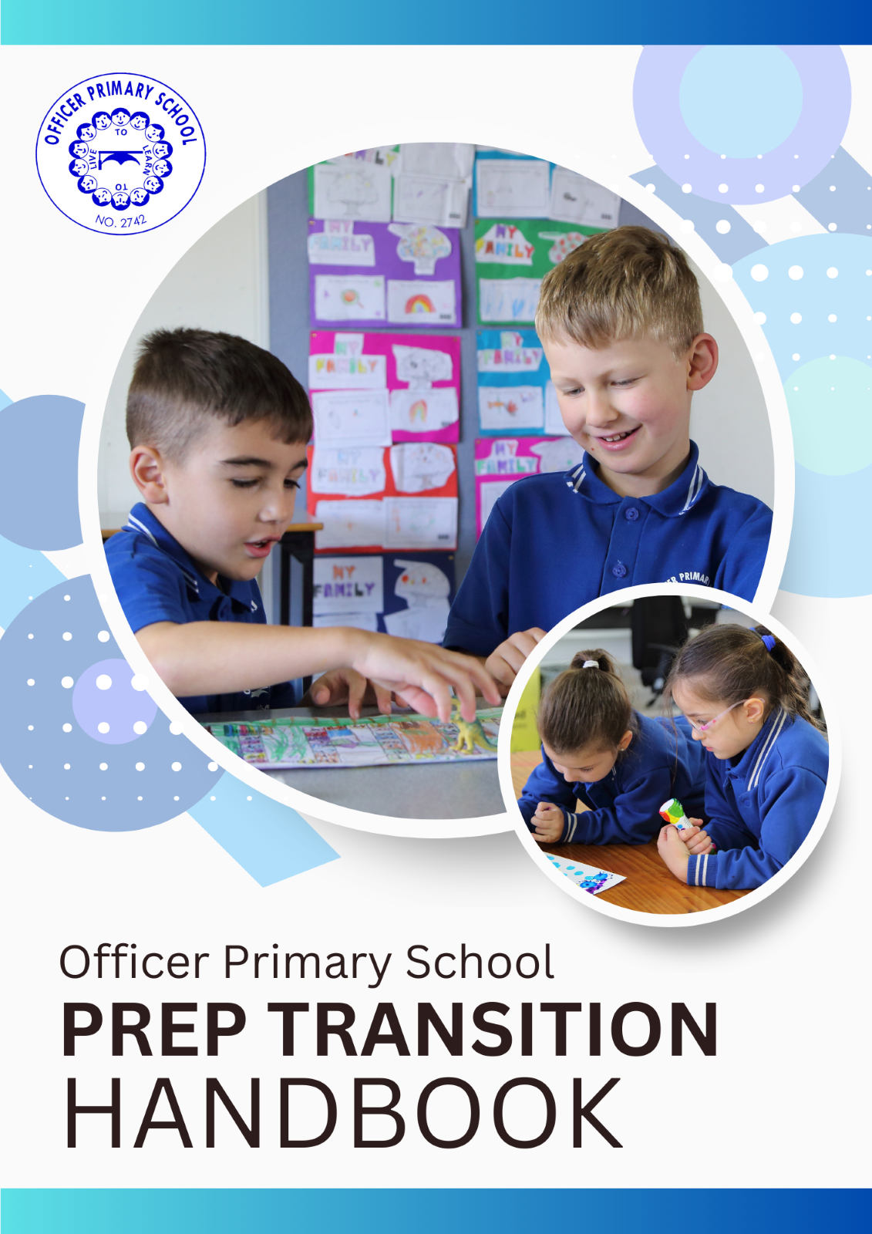

Page of Contents

School Contacts Details
Welcome to Officer Primary School
Preparing Your Child for School
School Routines
2025 Prep Starting Dates and Times
Drop Off and Pick Up Arrangements
Things to do before 2025
Compass
School Bag
Keys Things to Note
Home and School
How Can I Help?
School Facilities and Programs

School Contact Details

Tel. (03) 5943 2315
Fax. (03) 5943 1078

Email: officer.ps@education.vic.gov.au
Address: 13-23 Tivendale Road, Officer, 3809
Facebook: Officer Primary School
Website: www.officerps.vic.edu.au

Leadership Team:
Mati Azadzoi – Principal
Julie Barrow – Business Manager
Luisa Prendergast – Literacy Learning Specialist
Julian De Zilva – Numeracy Learning Specialist
Emily Waldron – Student Engagement Leader
Nicole Peachey – Inclusion and Wellbeing Leader
Amber Augustus – Prep Teacher

Welcome to OPS

The first year of school is always filled with excitement, challenges and new milestones. At Officer Primary School, we aim to create a relaxed, secure and supportive environment to enable all children to thrive. We have a highly committed and energetic team who are looking forward to working with you to provide the best possible learning opportunities for your child.
Parent involvement is a key feature of our school, and we warmly invite you to become involved in the OPS community and your child’s education. A collaborative approach results in the development of positive attitudes and educational outcomes for our students.

SCHOOL VISION
Our vision is to promote an inclusive and diverse school culture that is welcoming for all. We aim for student growth in both their academic and social/emotional learning and promote a love of learning. We aspire for continuous improvement in all our students as we look forward to them becoming resilient, productive and cooperative global citizens. Officer Primary School provides a stimulating, engaging and holistic education to develop critical thinkers who always engage in rich experiences. We endeavour to ensure our students are happy and healthy.

G.R.O.W.T.H. (SCHOOL VALUES)
Gratitude
We appreciate the people and resources around us and act kindly
Respect
We behave appropriately all the time
Outstanding (Excellence)
We strive for excellence in all that we do
Wellbeing
We are always considerate of each other’s and our own health and happiness
Teamwork
We work together to achieve success and positive outcomes
Honesty
We are truthful in our conduct and actions all the time

Preparing your child for School

Moving into a school setting, students are encouraged to become independent and responsible learners. We support our students to grow and have success by working through some social and emotional skills. You can support your child by discussing and modelling these things at home.

- Listen carefully and follow simple directions.
- Respect their own and others’ personal property.
- Speak with confidence and kindness.
- Turn taking.
- Recognise their own name on their belongings.
- Using their own lunchbox.
- Manage their own toilet needs.
- Wash their hands thoroughly.
- Tidy up after themselves.
- Fasten their own shoes (we recommend Velcro in Prep)
- Be familiar with pick-up arrangements at the end of the school day.
- Ask for help if they need it .
- Put on and take off their jumpers.
- Recognise and describe how they feel (e.g. happy, hot, cold).

School Routines
As a parent you have assisted your child in progressing through the many and varied developmental milestones such as crawling, walking and communicating. You will be able to continue your valuable role as your child transitions from preschool to Prep and commences a new and exciting learning journey at OPS. It is important to acknowledge that not all children will master their learning at the same time. You can provide encouragement and opportunities to assist in the development of many skills – consistent praise of any effort and achievement is always beneficial. Most children will settle quickly and happily into the routine of school; however some may feel anxious about coming to school. Modelling good coping strategies and reinforcing the positive aspects will assist your child to feel secure in their new environment.

Example of a day in Prep
9:00-11:00am | Literacy: Reading, Writing, Letters and Sounds
11:00-11:30am | Recess
11:30am-1:15pm | Maths  Specialist Class (Auslan, Art, P.E.)
1:30pm-2:15pm | Lunchtime
2:15-3:15pm | Inquiry

Term One

Early Years Assessment
During the first term of school, our Prep students do not attend on Wednesdays. On one of these Wednesdays each student will be required to attend an individual student assessment at school. These student assessments are designed to assist teachers in gathering information about your child’s literacy and numeracy understandings. This information helps us to provide the very best teaching and learning programs to cater for the individual needs of your child and to ensure that starting school is a rewarding experience.

Learning Program
During the first term of school, your child will be learning a lot. However, be patient with this learning progress. A lot of our learning in the first term will be around social and emotional learning. It is also a big time to adjust to new routines, new people and new rules. Give your child some time and praise as they adapt to the rules and routine of school.

2025 Important dates and Times

See our Newsletter, Compass, our Website or our Facebook page for important date and times.
Key Dates 2025
2025 | Start date | Finish date
Term 1 | 28 January (students start 29 January in government schools) | 4 April
Term 2 | 22 April | 4 July
Term 3 | 21 July | 19 September
Term 4 | 6 October | 19 December

Drop Off and Pick Up Routines

Drop off:
The school gate opens at 8:50am each morning. On the first day, please walk your child to their classroom and help them locate their named locker and place their bag inside. Stay and play for a few minutes and then give them a big cuddle and remind them where you will pick them up from at the end of the day (the bottom of the stair is a highly visible spot). If your child shows signs of distress, make the classroom teacher aware. Repeat your assurance, and then leave. You can rest assured that the teacher will comfort your child and have them settled quickly. When we get the opportunity, we will ring you.
We encourage you to bring a special or photo for your child to have with them when they are missing you. It Is also nice to draw a little heart on their hand, and one on yours too, telling them when they miss you, they can give their heart a little rub and you’ll be with them.

Pick Up:
The school day finishes at 3:15pm. We encourage you to take the opportunity to have a quick chat to the classroom teacher if you need, or to have a look at the wonderful work your child has been involved in.
Make sure your child knows exactly where to meet and who will pick them up each day. Please notify the teacher if there is any change to avoid any confusion or uncertainty.

Early Pick Up:
If you need to pick up your child early from school, please let your child’s teacher or the office staff know. You will need to first go to the office and ask for your child to come to the office with their bag. You will need to sign them out at the kiosk. We understand that children need to go to appointments or holidays, but try not to make early leaving a regular thing as it will begin to impact on your child’s learning and growth.

Parking:
The school does not have a parent carpark. Please park in the designated parking areas on and around Tivendale Road. Do not park in the staff carpark. This is not safe for small children.

Things to do Before 2025

- Download and login to the Compass School Manager app and/or web-based portal.
- Make sure all clothing and belongings are clearly labelled.
- Attend our transition sessions and help your child to feel comfortable in our school setting.
- Try on the uniform. Have your child practise putting on and taking off their jumper.
- Support your child to learn personal self-care skills like wiping their nose, going to the toilet independently, washing their hands.
- Use their lunchbox at home. Can they take off the lid? Fill up their drink bottle?
- Help your child to understand what they can expect by talking about school in general. Make this a positive experience, telling them about the friends they will make, the things they will learn and the challenges they may face.
- Help them to identify their name. They do not have to be able to write their name, but being able to find it on their hat or bag is really helpful.

School Fees
Please see Parent Payment Policy 2025 located on our website.

Compass
Please make sure you have downloaded the Compass App. Compass is a portal that allows parents and carers to access up-to-date and meaningful information about your child.

With this app you can:
- Monitor and explain your child’s absence and/or lateness.
- Communicate with teachers.
- Update family details.
- View the school calendar and important dates.
- Download and view school reports.
- Book parent/teacher conferences
- Pay and provide consent for activities and excursions.
Follow this link for more information on how to use this app http://www.compass.education

A Prep School Bag

- A school bag – place a big name tag on the outside so your child can easily identify their bag
- A lunchbox – make sure it is easy to open and can hold enough food for a long day.
- Fruit snack – e.g., strawberries, apple, mango, banana, etc.
- Snack – muesli bar, fruit, biscuits, cheese, yoghurt, sultanas etc.
- Lunch – a sandwich, rice and vegetable, pasta, sushi, etc. Please make sure your child’s lunchbox contains not only energy inducing foods, but also foods they like.
- A refillable water bottle – please send your child to school with water only.
- School sunhat
- An art smock.
- OPS reader bag
- Spare underwear and socks in a named zip lock bag
- Library bag
- A teddy or family photo if they need a comfort item.
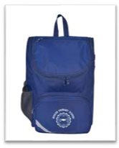

Hats are compulsory in Term One and Term Four.
Your child’s school bag should be large enough to fit their take home readers, lunchbox, clothing and schoolwork.

Key Things to Note

- A ‘Stationery Pack’ will be available to pick up from school. Please keep an eye on emails from OPS
- We encourage you to login to Compass daily as this is our primary means of communication.
- If consent/payment for excursions and incursions is not completed by the ‘due date’, your child will be unable to participate/attend.
- Full day absences MUST be reported via Compass on the day of absence (early in the morning or before 10:00am, to avoid email notification
- Students arriving to school after 9:00am or leaving during school hours MUST be signed in/out by a parent/carer via the Kiosk at the office.
- Students must NOT be left alone in the school grounds before 8:50am or after 3:30pm as the yard is unsupervised during this time.
- Parents and students are NOT permitted to walk through the staff carpark OR use it for parking.
- Riding of scooter, bikes, skateboards, etc., is NOT permitted in the school grounds at drop-off or pick-up (school and non-school children)

Home and School

- At Officer Primary, we regard the home/school relationship as an integral partnership between the family and school. School should not be a separate part of your child’s life, but they should compliment each other. Make yourself known to your child’s teacher and share your expectations, concerns and celebrations.
- Communication with the school is encouraged both formally and informally. Parents and teachers use many ways to keep in touch and share information. Contact with your child’s teacher can be made in person, by phone, by writing in your child’s diary or via email. It is advisable to make an appointment with the teacher to ensure they spend the time you need to discuss the matter.
- You will receive two Progress Reports for your child per year, and two Parent/Teacher conferences. This will give you some understanding of how your child is progressing whilst at school.

Parent participation is encouraged. We find great value in seeing our parents keep a close relationship with the school environment. Here are some ways you can get involved:
- Assist with morning classroom reading or attend school excursions and special events as a parent helper. A current Working with Children Check (WWCC) is required.
- Nominate for School Council.
- Assist with school fundraising.
- Attend our whole-school events.

How can I help my child?

As the first day of school approaches, it is essential to prepare our children for the challenges ahead by talking through and modelling ways of working through and solving these developmental milestones.

Physical Development:
- Feed themselves
- Unwrap food
- Undo/open their lunchbox
- Remove and replace a lid on a drink container
- Remove and insert a straw in a drink box
- Drink from a straw
- Get a drink from a school tap
- Peel a piece of fruit
- Pack and unpack their school bag
- Go to the toilet by themselves, use zips and buttons, tuck in clothing
- Flush the toilet
- Use a urinal
- Wash their hands
- Manage the taps

While accidents can happen at this age, teachers try to prevent these by regular visits to the toilets during the first few weeks of school. A change of clothes for school, placed in the bottom of your child’s school bag, is encouraged.

Dressing:
Sometimes children feel too hot or too cold so they must be able to cope with their school clothes by themselves. The best way to help children is to encourage them to dress themselves. If they get stuck, encourage them to ask for help.

Nose Blowing
It is important for health that children are aware when their noses need wiping or blowing and that they are able to do so themselves. The care of personal handkerchiefs and the correct disposal of tissues are also important steps to good health.

Social Development:
Primary school is a wonderful place for students to interact with children and adults older and younger than themselves. They develop the skills to help them to cope with the social aspects of life. Our Buddy Program was established to help Preps with this transition. Children learn to share, take turns, respect and listen to others and cooperate. Children often work in groups in school to develop these social skills. They need the same skills in the playground. You can develop your child’s social skills by:
- Taking them to playgroups/playgrounds.
- Role modelling interacting with others when things aren’t going their way e.g., someone is holding more than their share of toys.
- Practise asking for help when they need it.
- Modelling how to seek out friendships.
- Look for social stories at the library when you visit.

Emotional Development:
For some students, separating from their loved ones is challenging. It helps the child if the parent points out the enjoyable things the child will learn at school. “You will have other children to play with, paint pictures, play games, learn to read and use the computers and iPads”. If other members of the family are cheerful, encouraging and excited about the changes ahead then hopefully these feelings will influence the child’s transition to school. Remind them that their feelings are valid, “it’s ok to be scared, sad, worried etc., but remember your teacher cares about you and I will always be here to pick you up”.
Often children are incredibly cooperative and work really hard throughout the school day, which can often lead to intense feelings when they return to their ‘safe place’, their families. Your child may display different behaviours and emotions at the end of the day and may require extra food, love and attention – this is completely normal!
You can support your child by:
- Be honest about your emotions throughout the day, explain “I felt angry when….”
- Model and discuss different coping strategies e.g., 5 deep breaths, walking away, exercising, chatting to a friend, drawing a picture.
- Look into the Zones of Regulation which will be taught to your child at school. Discuss at different times of the day what zone each family member is in and why.

Literacy Skills:
Your child has been engrossed in the world of literacy since birth. Primary school brings Reading, Writing, Speaking and Listening skills to life. To support the Literacy development of your child we suggest:
- Encouraging your child to talk and involve children in family conversations and discussions – expect more than a YES / NO answer.
- Encourage your child to look at a person’s face when they are speaking, focusing on the habit of waiting their turn to answer or waiting to speak when the other person has stopped.
- Dress ups, play and singing provide great opportunities to practise speaking and listening too!
- Draw your child’s attention to signs, advertisements, number plates and packets.
- Read to your child at least once a day (when they are read to, they become aware that meaning can be obtained from print and reading can be a useful and pleasurable activity).
- Give your child the opportunity to hold the book and turn the pages. Let them point at the words, comment on the pictures and predict what might happen next.
- Give your child lots of opportunities to write, draw and colour using a variety of tools.
- Allow your child to see you reading a variety of materials.
- Try retelling a story to develop the notion of sequencing.
- Write lists together – shopping lists, birthday/Christmas lists.

Numeracy Skills:
Early preparation for maths can occur by:
- Helping your child count a few objects such as plates on the table, buttons on clothing etc.
- Asking your child to assist with the shopping – “Can you put 5 oranges in the bag?” – “I wonder how much the oranges weigh?”
- Talking to your child about time, e.g., “five minutes till bedtime”, “four sleeps until you go to the party”. Having an analogue clock in the house is really helpful!
- Letting your child find out when he/she can buy with a few coins.
- Talking to your child as he/she uses construction toys, e.g., “Can you make it bigger?” – “Find five blocks” – “Put a block on top of each carriage”.
- Letting your child play with water or sand etc. to learn how much will fit into different containers.
- Cooking together – “Can you get me ½ a cup of flour?” “What did we use more of… flour or milk?”

School Facilities and Programs

Buddies
During Term One, your child will meet their Year 6 Buddy. This is a student who will be allocated to support your child at school. Buddies will meet with each other on a weekly basis, complete activities together and socialise together. This program is set up so your child has a mentor in the school. This is a friendly face that your child can look for in the playground when they need some help. Officer Primary is a little school so your child’s buddy is usually close by. It’s a wonderful opportunity for your child to learn social skills and find out about the exciting things about school.

Enrichment Coaching
Officer Primary is proud to offer Enrichment Coaching at our school. This is an intervention-based program that supports the extension of students’ learning. There may come a time in your child’s education that they become part of this program. Our enrichment coach will send home a letter of permission before taking your child into their lessons. Our coach spends a lot of time within the classrooms getting to know the students and how they learn. They work alongside the teacher to ensure your child is getting the most out of these sessions.
During these sessions your child will be supported to learn an engage in the curriculum through hands-on experience. These are small sessions, with up to 6 students per group. This allows for individualised support, a calm and engaged environment and a chance for lots of questioning and trial and error. Please see Mati if you have any questions.

Specialists
Officer Primary are currently running some incredible Specialist programs.
- Physical Education
- Auslan
- Digital Technologies
- Science
- Art
- Library
Students enjoy these weekly experiences, a chance to learn new skills and empower themselves through creative outlets.
Students will need:
- An art smock for Art
- Wear running shoes on P.E. day

Before and After School Care
At Officer Primary we are grateful to have access to OSHC Club (Outside School Hours Care). Many students attend this facility on a regular basis. It is run out of one of the classrooms near the oval. Students can attend from 6:30am till the school bell goes. Here they can access breakfast and some time to settle into the school day. After school students can attend from 3:15 – 6.30pm. They will receive an afternoon snack, some outdoor time and lots of time to interact with their peers. Please visit http://www.oshclub.com.au/find-us/officer-primary-school/ if you would like to book in your child and look into the fees to use this service.

Breakfast Club
Officer Primary supports families by offering our students free access to breakfast on Tuesday and Thursday mornings. This has been created to help those families who would appreciate the financial support, those running late in the morning and for those students who need a quiet space and a friendly face to start the day. Students are offered things like cereal, toast, baked beans and fruit. Students should arrive at 8:15am to eat before they enter their classroom. This is run out of the library.

Assemblies
Assemblies run every second Friday at 2:30pm. This is where students receive awards, birthdays are celebrated and events are talked about.

Thank you for reading our Prep Transition Handbook. Please come and chat with Mati or our other staff if you have further questions. Welcome to the OPS community.

